Experiment 1
Aim:- Draw an E-R diagram from given entities and their attributes
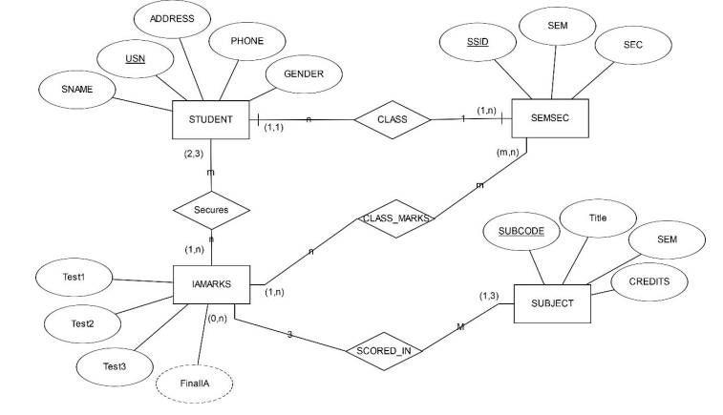
Experiment 2
Aim:- Convert the E-R diagram into a Relational model with proper constraints.
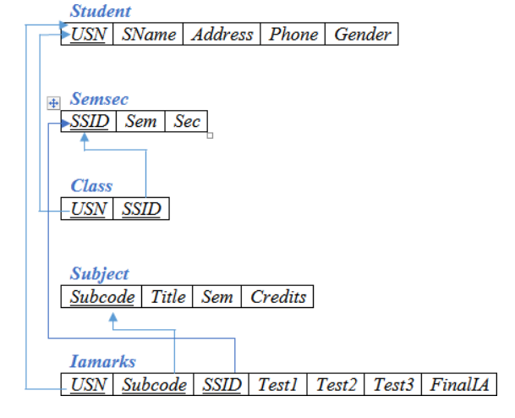
Experiment 3
AIM:- Write queries to execute following DDL commands :
CREATE :Create the structure of a table with at least five columns
ALTER: Change the size of a particular column.
- Add a new column to the existing table.
- Remove a column from the table.
DROP: Destroy the table along with its data.
Procedure: -
- Create a database .
  - create DATABASE assignment;
- Create
Table and Insert five coloumn .
  - CREATE TABLE student(USN INT, SName VARCHAR(14),
address VARCHAR(40),Phone VARCHAR(12), Gender VARCHAR(6));
- To view the table:
  - SELECT * FROM student;
  - 
- ALTER
Change the size of a particular column.
- ALTER TABLE student modify Gender varchar(10);
Add a new column to existing Table.
  - ALTER Table student ADD email varchar(20);
  - 
- Delete a column from Existing Table;
  - alter Table student DROP column email;
- DROP:
Destroy TABLE Along with its data
  - drop table student;
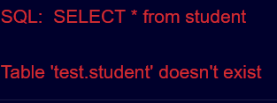
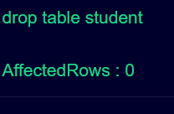

Experiment-4
AIM:- Write queries to execute following DML commands :
INSERT: Insert five records in each table.
UPDATE: Modify data in single and multiple columns in a table
DELETE: Delete selective and all records from a table
Procedure: -
INSERT
- Create five table
  - STUDENT
CREATE TABLE student(Eno INT, firstName VARCHAR(14), lastname VARCHAR(14),address VARCHAR(40),city VARCHAR(10));
- INSERT INTO student VALUES
(0012021,'Kamar','Burari',755762302,'M');
- INSERT INTO student VALUES
(0022021,'Shruti','Rohini',905862302,'M');
- INSERT INTO student VALUES (0032021,'Muskan','Aadarsh_Nagar',655561302,'M');
- INSERT INTO student VALUES (0042021,'Isha','Rohini',955961302,'M');
- INSERT INTO student VALUES (0052021,'Vanshu','Ghaziabad',855162302,'M');
  - SEMSEC
CREATE table SEMSEC(
SSID INT,SEM INT, SEC VARCHAR(6));
- INSERT into SEMSEC VALUES(1,2,'A');
- INSERT into SEMSEC VALUES(2,2,'A');
- INSERT into SEMSEC VALUES(3,2,'B');
- INSERT into SEMSEC VALUES(4,3,'A');
- INSERT into SEMSEC VALUES(5,3,'A');
  - CLASS
CREATE table CLASS(
USN INT,SSID INT);
- INSERT into CLASS VALUES(12021,1);
- INSERT into CLASS VALUES(22021,2);
- INSERT into CLASS VALUES(32021,3);
- INSERT into CLASS VALUES(42021,4);
- INSERT into CLASS VALUES(52021,5);

  - SUBJECT
CREATE table SUBJECT(
SUBCODE INT,Title VARCHAR(10),SEM INT, Credits INT
);
- INSERT into subject VALUES(012,'DBMS',2,2);
- INSERT into SUBJECT VALUES(013,'WEBD',2,2);
- INSERT into SUBJECT VALUES(014,'DSA',2,2);
- INSERT into SUBJECT VALUES(015,'ES',2,1);
- INSERT into SUBJECT VALUES(016,'DM',2,2);
  - IANMARKS
CREATE table IAMARKS(
USN INT,SUBCODE INT,SSID INT,
test1 INT, test2 INT, test3 INT,
FinalIA INT
);
- INSERT into IAMARKS VALUES(12021,012,1,87,92,90,288);
- INSERT into IAMARKS VALUES(22021,013,1,86,92,90,287);
- INSERT into IAMARKS VALUES(32021,014,1,84,96,90,278);
- INSERT into IAMARKS VALUES(42021,015,1,85,92,97,284);
- INSERT into IAMARKS VALUES(52021,016,1,84,91,94,281)
- UPDATE
Modify data in single and multiple column in a table;
Single :
- update student set SNAME='Kamar Alam' where usn = 12021
- 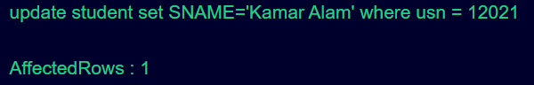
Multiple:
- update student set address='Delhi' where gender = 'f'
- 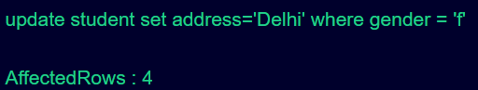
- Delete
Selective:
- DELETE FROM student where address='Burari';
- 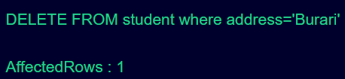
All record:
- DELETE FROM Student; 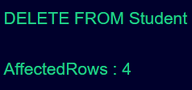.
Experiment 5
AIM:- Write queries to execute following DML command :
SELECT:
Retrieve the entire contents of the table.
Retrieve the selective contents (based on provided conditions) from a table.
Retrieve contents from a table based on various operators i.e. string operators,
logical operators and conditional operators,Boolean operators.
Sort the data in ascending and descending order in a table on the basis of one
column or more than one column.
Procedure:-
- Retrieve the entire content of the table
SELECT * From iamarks;
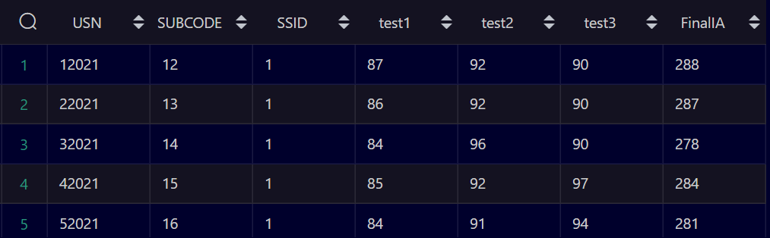
- Retrieve the selective contents ( based on provided condition) from a table.
Retrieve contents from a table based on various operator i.e string operators,

  - Logical operator
SELECT * from iamarks where test1=87 OR test2=90;
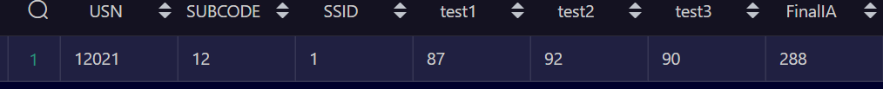
  - String
SELECT SUBSTRING(USN, 1, 5) AS ExtractString
FROM iamarks;
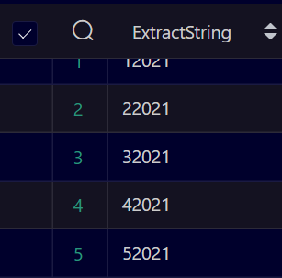

- Sort the data in ascending and descending order in a table on the basis of one or more than one column
Ascending
SELECT * from iamarks order by finalia ;
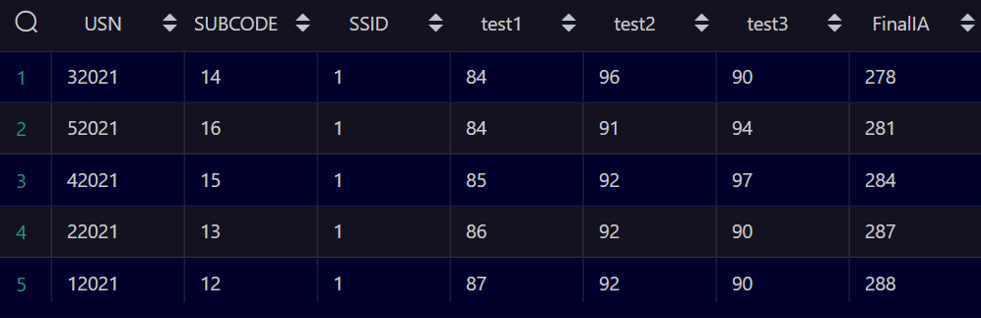
Descending
Select * From iamarks order by finalia DESC;
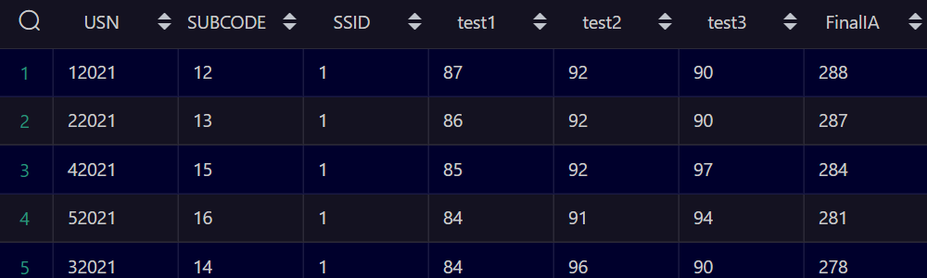
BY Using Multiple column
SELECT * from iamarks order by finalia ,subcode ;
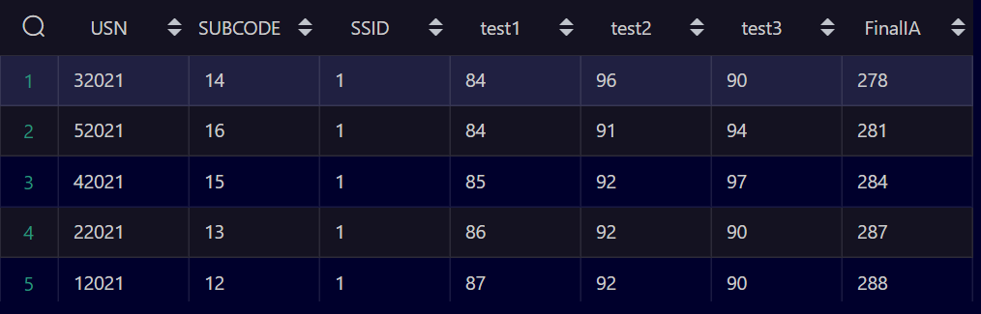

Experiment 6
Aim:-Create a table using following integrity constraints:
Primary Key, Unique Key, Not NULL ,Check ,Default.
Procedure:-
1.Primary key Constraints.
- Create a Table and Set (ID) as a Primary Key;
CREATE TABLE ConstraintDemo1
(
ID INT PRIMARY KEY,
Name VARCHAR(50) NULL
);
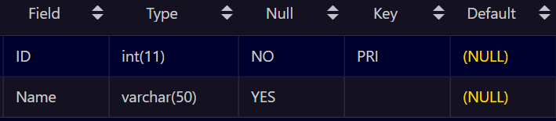
- Create a Table Using Unique key
CREATE TABLE Persons (
ID int NOT NULL,
LastName varchar(255),
FirstName varchar(255),
Age int,
UNIQUE (ID)
);
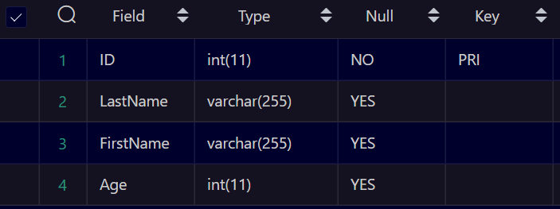
- Create a Table using Not NULL Constraints:
CREATE TABLE ConstraintDemo1
(
ID INT NOT NULL,
Name VARCHAR(50) NULL
);
Now insert NULL value to confirm whether it’s working or not.
INSERT INTO ConstraintDemo1 VALUES (NULL,'Shruti');

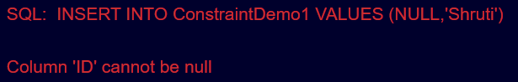
- Create a table Using Check Constraints:
CREATE TABLE check_constrain
(
ID INT PRIMARY KEY,
Name VARCHAR(50) NULL,
Salary INT CHECK (Salary>0)
);
- Put a negative Value in Salary column to verify Check Condition
INSERT INTO check_constrain VALUES (3,'Shruti',-123);
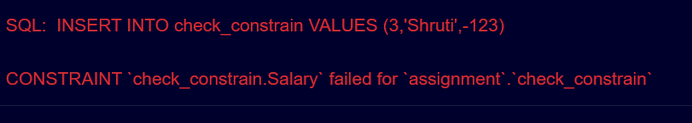
- Create a table using Default Constraints:
CREATE TABLE default_constrain
(
ID INT PRIMARY KEY,
Name VARCHAR(50) NULL,
EmployeeDate DATETIME NOT NULL DEFAULT CURRENT_TIMESTAMP
)
- Now insert data and leave employee date as empty.
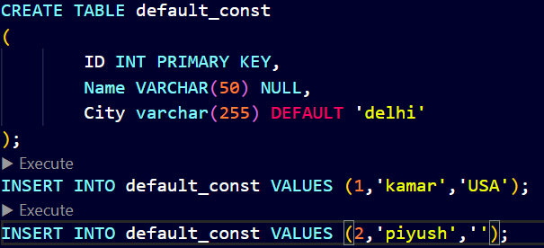

- Default Value get Inserted Automatically i.e City (Delhi)
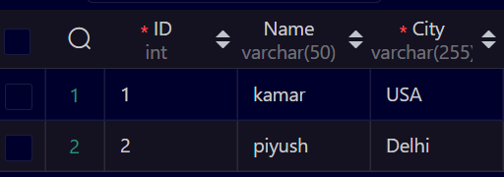

- Alter table add Foreign Key
- ALTER TABLE iamarks add FOREIGN KEY (USN) REFERENCES class(USN);

Experiment 7
Write queries to execute following Aggregate functions
- Sum, Avg, Count, Minimum and Maximum value of a numeric column of a table using aggregate function
Procedure:-
SUM:
- Select sum(test1) from iamarks;

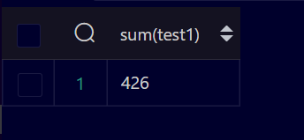

AVERAGE:
- Select avg(test1) from iamarks;

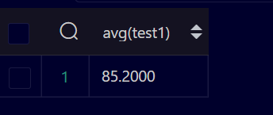

MIN:
- Select MIN(test1) from iamarks;
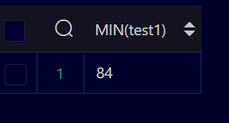

MAX:
- Select Max(test1) from iamarks;
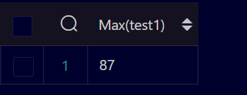

Experiment 8
AIM: Retrieve data from a table using alias names .
Procedure:-
SELECT test1 +1 as 'unit1' FROM iamarks
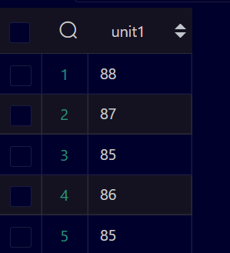

Experiment 9
Aim: Retrieve data of a table using nested queries.
Procedure:-
SELECT (Title) FROM subject where SUBCODE>14 IN (
SELECT test1 from iamarks WHERE usn>3000
);

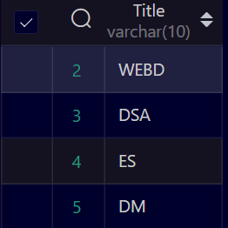

Experiment 10
AIM: Retrieve data from more than one table using inner join, left outer, right outer and full outer joins
Inner join:
SELECT iamarks.test1,iamarks.test3,subject.title FROM iamarks inner JOIN subject ON iamarks.SUBCODE;
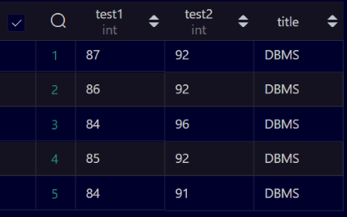
Left outer join:
SELECT iamarks.test1,iamarks.test3,subject.title FROM iamarks LEFT JOIN subject ON iamarks.SUBCODE;

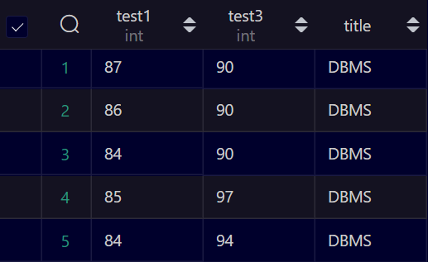
Right Outer joint:
SELECT iamarks.test1,iamarks.test3,subject.title FROM iamarks RIGHT JOIN subject ON iamarks.SUBCODE;
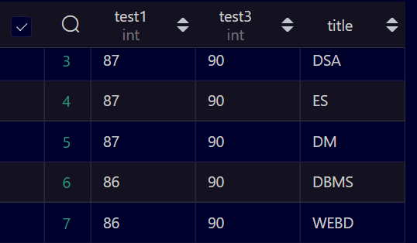

Full Outer joint:

Experiment-11
AIM: Create view from one table and more than one table.
Procedure:
create view present as select FSName, SName from practice, demo where practice.SNo= demo.SNo;
create view past as select FSName from practice where SNo>=0;


Experiment 13
AIM: Consider the Insurance company’s Database given below. The primary keys are
underlined and the data typesare specified.
PERSON(driver_id# : string, name : string, address : string)
CAR(regno : string, model : string, year : int)
ACCIDENT(report_number : int, acc_date : date, location : string)
OWNS(driver_id# : string, regno : string)
PARTICIPATED(driver_id# : string, regno : string, report_number : int,
damage_amount :number(10,2) )
(i) Create the above tables by properly specified the primary key and the
foreign key
(ii) Enter at least five tuples for each relation
(iii) Demonstrate how you can
a. Update the damage amount for the car with a specific regno, the
accident with report number 12 to 25000.
b. Add a new accident to the database.
(iv) Find the total number of people who owned cars that were
involved in accident in2002.
(iv) Find the number of accident in which cars belonging to a specific
models were involved.
create table person(driver_id varchar(10),name varchar(10),address varchar(10),primary key(driver_id));
create table car(regno varchar(10),model varchar(10),year int,primary key(regno));
create table accident(report_number int,accd_date date,location varchar(10),primary key(report_number));
create table owns(driver_id varchar(10),regno varchar(10),primary key(driver_id,regno),foreign key(driver_id) references person(driver_id),foreign key(regno) references car(regno));
create table participated(driver_id varchar(10),regno varchar(10),report_number int,damage_amount int,primary key(driver_id,regno,report_number),foreign key(driver_id) references person(driver_id),foreign key(regno) references car(regno),foreign key(report_number) references accident(report_number));

insert into person values('D192','&name','delhi');
insert into person values('D193','kamar','burari');
insert into person values('D194','shruti','rohini');
insert into person values('D195','Sahil','sultan');
insert into person values('D196','karan','china');

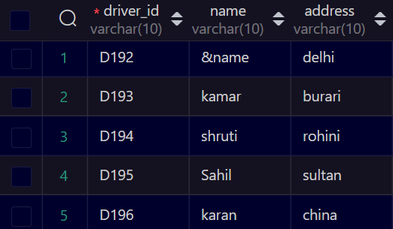

insert into car values('DL8182','Ertiga',2022);
insert into car values('DL9258','swift',2022);
insert into car values('DL2457','bMWx5',2017);
insert into car values('DL1257','mercdes',2012);
insert into car values('DL1221','Rollce',2012);

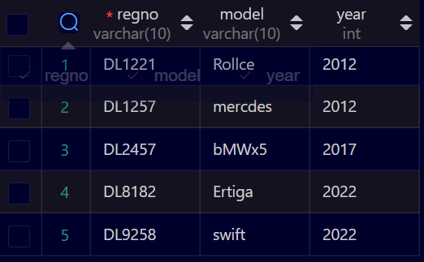
insert into accident values(1234,'2022-07-12','Delhi');
insert into accident values(1235,'2022-06-11','up');
insert into accident values(1236,'2022-01-11','banglore');
insert into accident values(1237,'2022-01-11','banglore');
insert into accident values(1238,'2021-03-11','chennai');
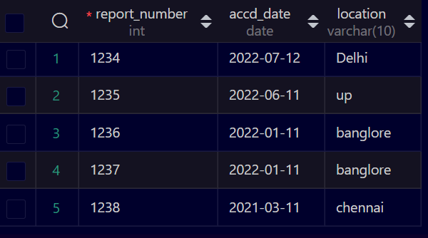
insert into owns values('D190','dl8213');
insert into owns values('D193','dl9113');
insert into owns values('D194','dl9116');
insert into owns values('D195','dl9616');
insert into owns values('D196','dl9617');

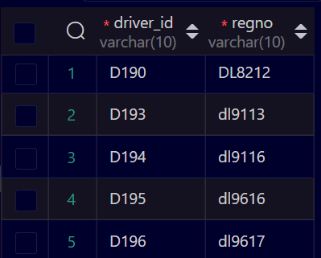

select count(distinct o.driver_id) as People from owns o,participated p,accident a where a.accd_date like
'2008' and o.regno=p.regno and p.report_number=a.report_number;


select count(0) as Totalcars from car c,participated p where c.regno=p.regno and c.model='swift';

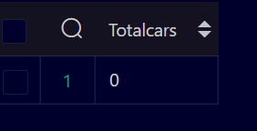

Experiment-14
AIM: Consider the following schema of a library management system.Write the SQL
queries for the questions given below;
Student(Stud_no : integer, Stud_name: string)
Membership(Mem_no: integer, Stud_no: integer)
Book_(book_no: integer, book_name:string, author: string)
lss_rec_(iss_no:integer, iss_date: date, Mem_no: integer, book_no: integer)
(i) Create the tables with the appropriate integrity constraints
(ii) Insert around 10 records in each of the tables
(iii)Display all records for all tables
(iv)List all the student names with their membership numbers
(v) List all the issues for the current date with student and Book names
(vi) List the details of students who borrowed book whose author is Elmarsi & Navathe
(vii) Give a count of how many books have been bought by each student
(viii) Give a list of books taken by student with stud_no as 1005
(ix) Delete the List of books details which are issued as of today
(x) Create a view which lists out the iss_no, iss _date, stud_name, book
Name
Procedure:
(i) Create the tables with the appropriate integrity constraints
create table student(stud_no int(5) primary key,stud_name varchar(15));
create table membership(mem_no int(5) primary key,stud_no int(5) references student(stud_no));
create table book_(book_no int(5) primary key,book_name varchar(20),author varchar(2));
create table lss_rec_(iss_no int primary key,iss_date date,mem_no int(5) references membership(mem_no),book_no int(5) references book(book_no));
(ii) Insert around 10 records in each of the tables
insert into student values (1001,"Kamar");
insert into student values (1002,"shruti");
insert into student values (1003,"muskan");
insert into student values (1004,"sahil");
insert into student values (1005,"Aditya");
insert into student values (1006,"isha");
insert into student values (1007,"gagan");
insert into student values (1008,"Nishtha");
insert into student values (1009,"niwanshu");
insert into student values (1010,"vanshu");
insert into student values (1011,"shubham");
- Insert into membership table
insert into membership values(101,1001);
insert into membership values(102,1002);
insert into membership values(103,1003);
insert into membership values(104,1004);
insert into membership values(105,1005);
insert into membership values(106,1006);
insert into membership values(107,1007);
insert into membership values(108,1008);
insert into membership values(109,1009);
insert into membership values(110,1010);
insert into membership values(111,1011);
- Insert into book_ table
insert into book_ values (1,"Harry Potter","JK");
insert into book_ values (2,"Story of my life","Helen Keller");
insert into book_ values (3,"Tell me a story","Ravinder Singh");
insert into book_ values (4,"Can love happen","Ravinder Singh");
insert into book_ values (5,"Your dreams are mine now","Ravinder Singh");
insert into book_ values (6,"the perfect us","Durjoy Dutta");
insert into book_ values (7,"Someone like u","Durjoy Dutta");
insert into book_ values (8,"The open door","Helen Keller");
insert into book_ values (9,"Five points someone","Chetan Bhagat");
insert into book_ values (10,"One indian girl","Chetan Bhagat");
insert into book_ values (11,"DBMS","Elmarsi & Navathe");
- Insert into Iss_rec_
insert into lss_rec_ values(01,"1998-05-08",104,10);
insert into lss_rec_ values(02,"1998-03-08",102,9);
insert into lss_rec_ values(03,"1998-04-08",103,8);
insert into lss_rec_ values(04,"1998-06-08",101,7);
insert into lss_rec_ values(05,"1998-07-08",105,6);
insert into lss_rec_ values(06,"1998-08-08",106,5);
insert into lss_rec_ values(07,"1997-01-09",107,4);
insert into lss_rec_ values(08,"1996-08-10",108,3);
insert into lss_rec_ values(09,"1995-05-11",109,2);
insert into lss_rec_ values(010,"1995-05-12",110,1);
insert into lss_rec_ values(011,"1995-05-12",111,11);

(iii)Display all records for all tables
- Retrieve records from student table.
- SELECT * from student;

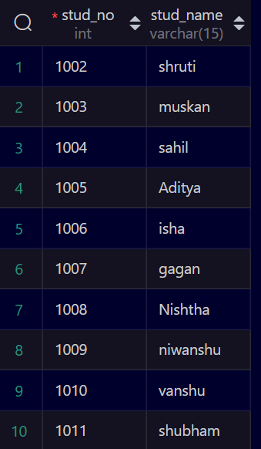
- Retrieve records from membership table.
SELECT * from membership;

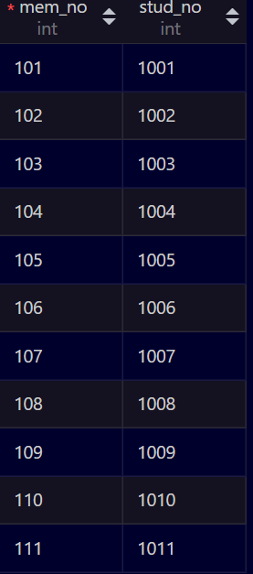
- Retrieve records from lss_rec_ table.
- SELECT * from lss_rec_;
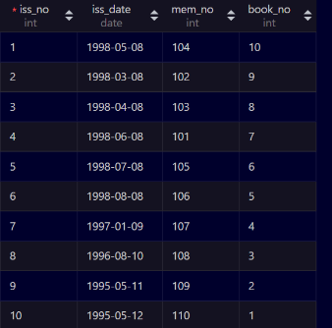

- Retrieve records from book_ table.
SELECT * from book_;

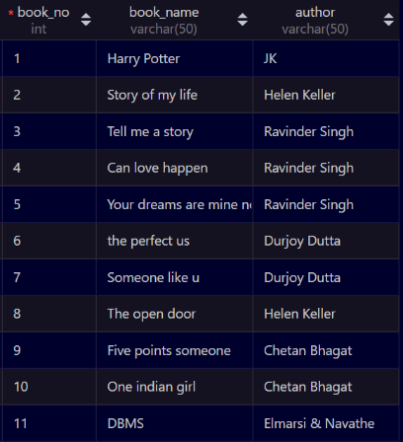

(iv) List all the student names with their membership numbers.
select stud_name, mem_no from student s, membership m where m.stud_no=s.stud_no;
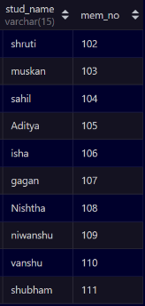

(v) List all the issues for the current date with student and Book names.
select i.iss_no, s.stud_name, b.book_name from lss_rec_ i, membership m, student s, book_ b where i.mem_no=m.mem_no and m.stud_no=s.stud_no and i.iss_date=curdate();

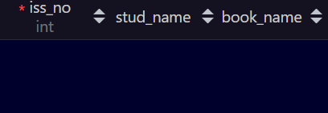

(vi) List the details of students who borrowed book whose author is Elmarsi & Navathe.
select * from student where stud_no in(select stud_no from membership where mem_no in (select mem_no from lss_rec_ where book_no in(select book_no from book_ where author="Elmarsi & Navathe")));

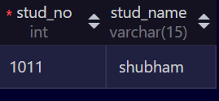

(vii) Give a count of how many books have been bought by each student
select s.stud_no, count(i.book_no) from student s, membership m, book_ b, lss_rec_ i where s.stud_no=m.stud_no and b.book_no=i.book_no group by s.stud_no;

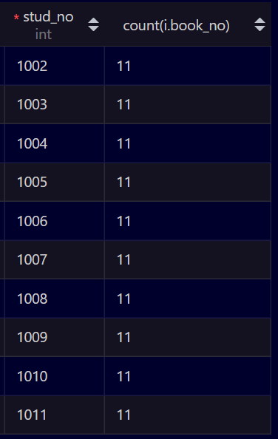
(viii) Give a list of books taken by student with stud_no as 1005
select book_name from book_ where book_no in (select book_no from lss_rec_ where mem_no in(select mem_no from membership where stud_no in(select stud_no from student where stud_no=1005)));

(ix) Delete the List of books details which are issued as of today.

delete from book_ where book_no in (select book_no from lss_rec_ where iss_date=curdate());

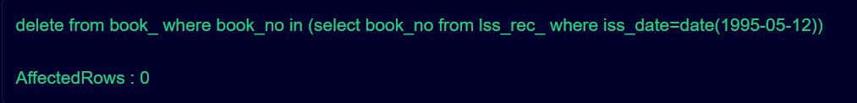
(x) Create a view which lists out the iss_no, iss _date, stud_name, book Name
create view vw_ as select i.iss_no ,i.iss_date , s.stud_name , b.book_name from lss_rec_ i , student s, book_ b , membership m where s.stud_no=m.stud_no and b.book_no=i.book_no and m.mem_no=i.mem_no;

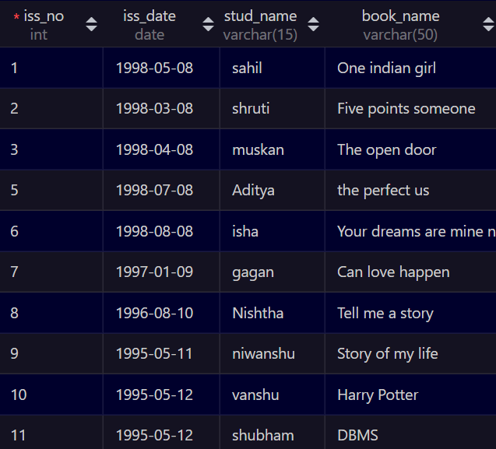

Q15 Use the relations below to write SQL queries to solve the business problems specified.
CLIENT (clientno#,name, client_referred_by#)
ORDER (orderno#, clientno#, order_date, empid#)
ORDER_LINE (orderno#, order line number#, item_number#, no_of_items, item_ cost,shipping_date)
ITEM (item_number#, item_type, cost)
EMPLOYEE (empid#, emp_type#, deptno, salary, firstname, lastname)
Notes:
a. Column followed by # is the primary key of the table.
b. Each client may be referred by another client. If so, the client number of the referring client is stored in referred_by.
c. The total cost for a particular order line = no_of_items * item_cost.c.

Write queries for the following
- Create all the above tables.
create database business;
create table client(clientno int(5),name varchar(30),client_referred_by int);
create table order_line(orderno int, order_line_number int, item_number int,no_of_item int, item_cost int,shipping_date date);
create table orders(orderno int,clientno int,order_date date,empid int);
create table item(item_number int,item_type varchar(30),cost int);
create table employee(empid int,emp_type varchar(20),deptno int,salary int,firstname varchar(20),lastname varchar(20));
- Insert at least five records.
insert into client values(1,'Kamar',4);
insert into client values(2,'RONAK',3);
insert into client values(3,'ROHIT',2);
insert into client values(4,'Ashish',1);
insert into client values(5,'KASHISH',5);

insert into employee values(101,'CLERK',4,15000,'RITIK','BANAL');
insert into employee values(102,'MANAGER',3,55000,'MAHESH','PATHAK');
insert into employee values(103,'CLERK',4,15000,'RITIKA','MITTAL');
insert into employee values(104,'OFFICER',5,23000,'RAJESH','SINGH');
insert into employee values(105,'OFFICER',5,25000,'KRITIKA','AGGARWAL');
- Display all the rows and columns in the CLIENT table. Sort by client name in reverse alphabetical order.
insert into orders values(10,4,'2022-03-04',101);
insert into orders values(12,3,'2022-05-04',102);
insert into orders values(13,2,'2022-09-04',103);
insert into orders values(14,1,'2022-8-04',104);
insert into orders values(15,5,'2022-2-04',105);
insert into item values(40,'Stationery',500);
insert into item values(41,'Grocery',570);
insert into item values(40,'Stationery',15000);
insert into item values(40,'Machinery',28000);
insert into item values(40,'Machinery',30000);
- Display the item number and total cost for each order line (total cost = no of items X item cost). Name the calculated column TOTAL COST.
select * from client order by name desc;
select item_number,no_of_item*item_cost as 'Total Cost' from order_line;
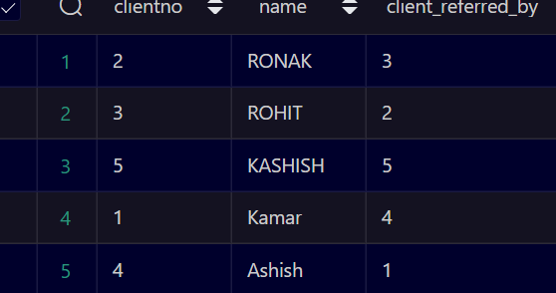
(v) Display all the client numbers in the ORDER table. Remove duplicates.
(vi) Display the order number and client number from the ORDER table. Output the result in the format. Client <clientno> ordered <orderno>
insert into order_line values(10,20,40,5,500,'2022-05-04');
insert into order_line values(12,21,41,6,500,'2022-06-04');
insert into order_line values(13,22,42,9,500,'2022-10-04');
insert into order_line values(14,23,43,2,500,'2022-09-04');
insert into order_line values(15,24,44,3,500,'2022-03-04');

- Display full details from the ORDER_LINE table where the item number is (first condition) between 1 and 200 (no > or < operators) OR the item number is greater than1000 AND (second condition) the item cost is not in the list 1000, 2000, 3000 OR the order number is not equal to 1000.
select distinct (clientno)from orders;
select clientno as 'Client',orderno as 'Ordered' from orders;
select * from order_line where item_number between 1 and 200 OR item_number>1000 AND item_cost not in(1000,2000,3000) OR orderno!=1000;
select name,order_date from client,orders where client.clientno=orders.clientno;
SELECT NAME ,ORDER_DATE FROM CLIENT , ORDERS WHERE CLIENT(.) = CLIENT ;
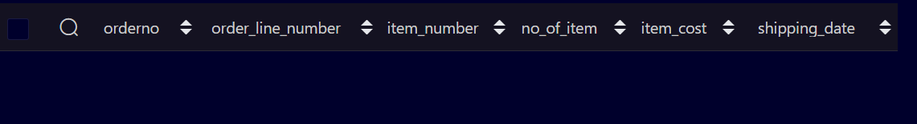
(viii) Display the client name and order date for all orders.
select name,order_date from client,orders join client.clientno=orders.clientno
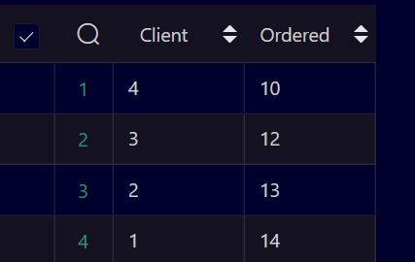
(ix) Repeat query (6) but also display all clients who have never ordered anything.
(x) Display the client name and order date for all orders using the join keywords.
(xi) Display the client name and order date for all orders using the JOIN method.
(xii) Display the client number, order date and shipping date for all orders where the shipping date is between three and six months after the order date.

(xiii) Display the client number and name and the client number and name of the person who referred that client.
(xiv) Display the client name in upper case only and in lower case only.
(xv) Display the second to fifth characters in each client name.

